

All Projects and Scripts – What, Where and How

Faisal Maqbool **–** Associate Data Analyst (March 2018 – September 2019)

Following are the projects, scripts, reports and apps on which Faisal Maqbool worked on along with description, sponsors and stakeholders of each project:

1. **Big Schedules (MENA)**

**Description:** Automation of the schedules extraction from <https://www.bigschedules.com>website source as per required parameters entered by the user in input file called **“Data.xlsx”** to eliminate the manual work and save operator’s time, which will not only improve operational efficiency and affect the overall performance of ocean import/export positively.

**Stakeholders:** Charbel Mrad, Gaelle Makhol, Rajesh Thoppil, Elias Khattar

**Location:** LHE F:\FTP\GBO\FaisalTransition\Big Schedules-Automation

**Documentation:** F:\FTP\GBO\FaisalTransition\Big Schedules\Docs\BigSchedulesProject.docs

**Tools and Tech:** Python, Excel, Selenium, Python

**To Contribute:** <https://github.com/faisalmaqbool94/BigSchedulesScrapp>

1. **Decathlon - CAPE (INDIA) (Continued...)**

**Description:** Automation of the consolidation process for Decathlon is based on using cape system: <https://cape-asia.decathlon.net/capetm/index.jsp>for each order number all the items are consolidated and containerize in Cape as per given details. This whole process is very time consuming. We have started to automate the process based on Chrome using Python, Selenium, and Chrome driver.

**To contribute:**

<https://github.com/faisalmaqbool94/ExploratoryNotebooks/blob/master/Decathlon.py>

**Update:**

* Input file is designed in a standard format
* Half of the process is done as per given presentations. See Locations
* System configuration files for passwords are not yet created. Using static credentials in code for now. Validation and protection will be added later.
* Written script is just following correct use case as per given process. Need to update the exception cases
* A lot of validation and testing is required (unit/system) as the system is complex and requires live data to process.

**Challenges:**

* Unable to open website source.
* Requires live data
* Aggressive testing required along with validation
* Should be exceptions less as the process is sensitive. Cannot afford to make mistake with consolidation or containerization
* Security and SSL (proxy) settings should be matched with our network
* Following screenshots are examples of issues we faced while development

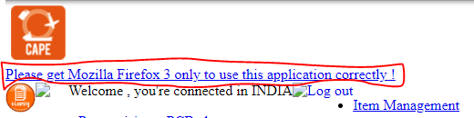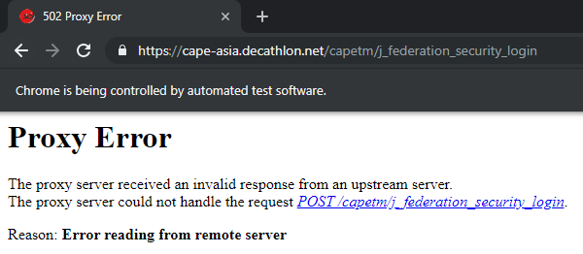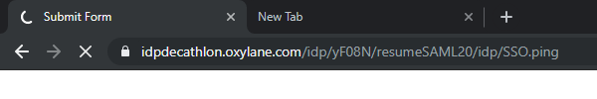

**Stakeholders:** Toufic Hankache, RR Babu, Rajesh Thoppil, Elias Khattar, Khalil Haddad

**Location:** LHE F:\FTP\GBO\FaisalTransition\Decathlon

**Documentation:** F:\FTP\GBO\FaisalTransition\Decathlon\PPTs

**Tools and Tech:** Python, Excel, Chrome Driver, Selenium Wrapper

1. **Airway Bill Preparation – GAP (KHI)**

**Description:** From getting draft bill of lading instruction to preparation of AWBs, for GAP customer despite having a standard process, all shipments were logged manually. So we wrote two scripts first to convert all the drafts in bulk and prepare input for ETMS and a desktop script to create AWBs. Scope includes updating all the screens as per instructions, distinguish between files which have onhand already created and ones to create.

54th version rolled out.

**Stakeholders:** Safdar Jafri, Haris Meraj, Amin Gang, Safia Khannum

**Location:** LHE F:\FTP\GBO\FaisalTransition\GAP – Automation\HousePreparation\

**Paths:** F:\Scripting\Air export\KHI_GAP_DRAFT - where the house ETMS script is

**Paths:** F:\Scripting\Air export\KHI_GAP_DRAFT_AWB\Docs - where the drafts documents should be placed

**Documentation/Video:** F:\FTP\GBO\FaisalTransition\ GAP - AirwayBill\GapAutomation.gif

**Project Assessment and Procedure:** F:\FTP\GBO\FaisalTransition\ GAP - AirwayBill\Gap Project Assesment.docs\

F:\FTP\GBO\FaisalTransition\ GAP - AirwayBill\Gap ScriptProcedure.docs

**Tools and Tech:** AutoIt, Desktop script

1. **Adidas – Files Creation and Automation (LHE – KHI)**

**Description:** From file creation to advise creation each step is being done manually. The whole process involved a lot of manual work including data entry in system and files. Developed a tool which will not only update the Advice for particular shipment, generate csv file to process screen entries, and generating Advise files to send to customers with all the necessary details which are received in EDI messages. Also email draft will be generated to send to shipper.

**Stakeholders:** Imran Khan, Khamis Imtiaz, Faryar Rana, Sehrish Hanif

**Location:** LHE F:\FTP\GBO\FaisalTransition\Adidas\

**Paths:** F:\Adidas\BA_Sent\BA_Loader- where scripts and Macro is. Also is the execution path

**Documentation/Video:** F:\FTP\GBO\FaisalTransition\ Adidas\AdidasProcess.gif

**Project Assessment and Procedure:** F:\FTP\GBO\FaisalTransition\ Adidas\Assesment.docs\

F:\FTP\GBO\FaisalTransition\Adidas\ScriptProcedure.docs

**Tools and Tech:** Desktop script, Macro (VBA)

1. **BLDraft to ETMS (LHE)**

**Description:** BL instructions are received via email from customers and manually entered (BLHDR, BLDMRK, FCRHDR, and FCRDMRK). Wrote a script to populate respective screens as per BL instruction. Design the standard format as well to be used by automated way

**Stakeholders:** Imran Khan, Khamis Imtiaz, Faryar Rana, Sehrish Hanif, Umer Ejaz

**Location:** LHE F:\FTP\GBO\FaisalTransition\BLDraft to ETMS\

**Paths:** F:\scripting\Export\AmericanEagle\BLHRD_BLDMRK- where scripts is. Also is the execution path

**Project Assessment and Procedure:** F:\FTP\GBO\FaisalTransition\ BLDraft to ETMS\Assesment.docs\

F:\FTP\GBO\FaisalTransition\BLDraft to ETMS\ScriptProcedure.docs

**Tools and Tech:** Desktop script, Excel

1. **Onhand Sheets Generator Tool (KHI)**

**Description:** For each shipment, operators manually fills out an onhand sheet with all the details of the shipment in a standard format and then send to the Airport and edoc them. For each shipment this is very time consuming. Need to have an automated way to creating onhand sheet using data from ETMS. Created a tool create a tool for creating onhand Sheets for all the file numbers that will be entered in bulk. Tool will create all the onhand sheets in standard format and create separate files to fill edoc purpose as well.

**Stakeholders:** Safdar Jafri, Haris Meraj, Amin Gang, Safia Khannum

**Location:** LHE F:\FTP\GBO\FaisalTransition\ Onhand Sheet Preparation Tool \

**Paths:** F:\Scripting\Air export\Onhand_sheet - where scripts is. Also is the execution path

**Documentation/Video:** F:\FTP\GBO\FaisalTransition\ Onhand Sheet Preparation Tool\OnhandSheetGenerator.gif

**Project Assessment and Procedure:** F:\FTP\GBO\FaisalTransition\ Onhand Sheet Preparation Tool Assesment.docs\

F:\FTP\GBO\FaisalTransition\ Onhand Sheet Preparation Tool \ScriptProcedure.docs

**Tools and Tech:** Desktop script, Excel, Macro (VBA)

1. **Vouchers Creation and Tax Sheet Generation Tool (LHE)**

**Description:** For each transaction, from creating vouchers, updating tax sheets, linking to our system and printing all those vouchers operator spends a lot of time. Created a macro to do all those tasks and exclude manual work.

**Stakeholders:** Imran Khan, Sehrish Hanif, Khalid Javed, Ali Jamal

**Location:** LHE F:\FTP\GBO\FaisalTransition\Accounts\

**Documentation/Video:** F:\FTP\GBO\FaisalTransition\Accounts \Accounts ExcelWork Reduction.gif

**Project Assessment and Procedure:** F:\FTP\GBO\FaisalTransition\Accounts\Assesment.docs

F:\FTP\GBO\FaisalTransition\Accounts\ScriptProcedure.docs

**Tools and Tech:** Excel, Macro (VBA)

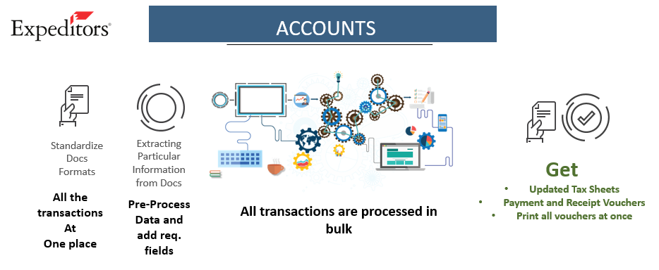

1. **AP Sheet Generation Tool (KHI) (Export & Import)**

**Description:** AP Process was very manual. Received Invoices are sent to accounts for payments along with a statement which is manually prepared and manually checked for adequate protection file by file. Developed a tool to generate AP sheets, update P/o under house using received invoices to send to accounts for payments along with a statement for adequate protection file by file. The tool will extract the line number and get the references from our system with protected amount and then generate the sheet.

**Stakeholders:** Safdar Jafri, Haris Meraj, Amin Gang, Safia Khannum, Zulkifle Abbas

**Location:** LHE F:\FTP\GBO\FaisalTransition\AP Process\

**Documentation/Video:** F:\FTP\GBO\FaisalTransition\AP Process\AP Process E-I.gif

**Project Assessment and Procedure:** F:\FTP\GBO\FaisalTransition\AP Process\Assesment.docs

**Tools and Tech:** Desktop script, Excel, Macro (VBA)

1. **GT-Nexus Downloading Documents & Summary Application (KHI)**

**Description:** Orders received from vendors for GAP, PO are manually checked in GAP system and against each PO operator has to download respective documents and detail summary of PO - this is time consuming and can be automated. Wrote a Python application to extract and download information from GAP GT-Nexus system

**Stakeholders:** Safdar Jafri, Haris Meraj, Amin Gang, Safia Khannum

**Location:** LHE F:\FTP\GBO\FaisalTransition\GT-Nexus\

**Tools and Tech:** Python, Excel, Selenium, Chrome Driver

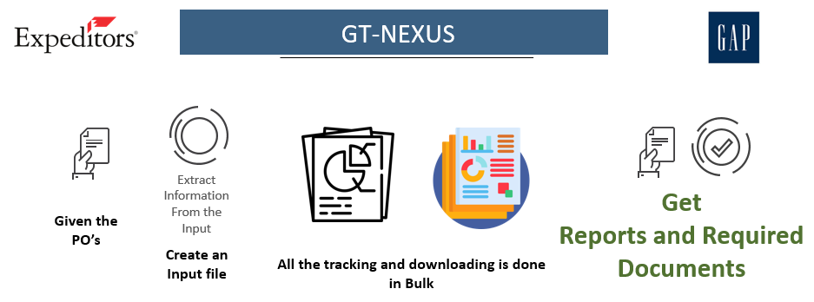

1. **Import General Manifest – IGM Tracker (KHI)**

**Description:** For every import shipment operator has to go to FBR website and track our master number for master and house indexes which takes up to an hour on a daily basis. We have developed an app which tracks down all the IGM numbers which operators update in CFIT.

**Stakeholders:** Safdar Jafri, Haris Meraj, Amin Gang, Safia Khannum, Zulkifle Abbas

**Location:** LHE F:\FTP\GBO\FaisalTransition\IGM Tracker\

**Tools and Tech:** Python, Excel, Selenium, Chrome Driver

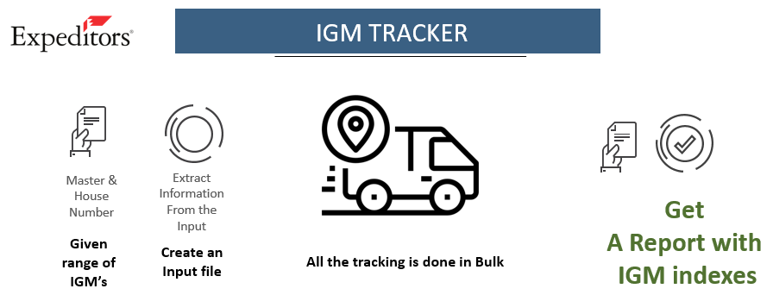

1. **Import Shipment Tracking (KHI)**

**Description:** For each shipment, user is manually managing all import shipments and their data which is time consuming and increase the workload. Created a report for all the import analytics and provide the visibility to the operator for his/her work.

**Stakeholders:** Safdar Jafri, Haris Meraj, Amin Gang, Safia Khannum, Zulkifle Abbas

**Location:** LHE F:\FTP\GBO\FaisalTransition\Import Tracking\

**Tools and Tech:** Inetsoft

**Link:** BranchReporting\Branch\Import Tracking\

1. **Distribution Dashboard (KHI & LHE)**

**Description:** Using the information from IGM tracker mentioned above and with other import information we have to update CFIT accordingly and generate AP. For this purpose we wrote a desktop script to update everything and all the consolidated information then used in tracking report mentioned above.

**Stakeholders:** Safdar Jafri, Haris Meraj, Amin Gang, Safia Khannum, Zulkifle Abbas

**Location:** LHE F:\FTP\GBO\FaisalTransition\Distribution Dashboard\

**Tools and Tech:** Inetsoft

**Link:** BranchReporting\Distribution\Branch\Dashboard\Distribution Dashboard

1. **Order Management – BLDraft to ETMS (KHI)**

**Ref: #5**

1. **Order Management – Item Checking Tool (KHI & LHE)**

**Description:** Using the information from packing lists provided by shippers we check for discrepancies manually from Dims and Poitm screen in ETMS. We wrote two scripts, one in python to extract data from packing list and then to check from ETMs wrote a desktop script to aid this problem and improve efficiency.

**Stakeholders:** Naeem Farooq, Amin Gang, Safia Khannum

**Location:** LHE F:\FTP\GBO\FaisalTransition\Items Checking Tool\

**Tools and Tech:** Python, Excel, Desktop Script

**Documentation/Video:** F:\FTP\GBO\FaisalTransition\Items Checking Tool\gifs

**Project Assessment and Procedure:** F:\FTP\GBO\FaisalTransition\Items Checking Tool\Assesment.docs

1. **Order Management – Containerization (KHI)**

**Description:** Using the information from container load plan provided by shippers we check for discrepancies manually from Dims and Poitm screen in ETMS and containerize as per CLP. We wrote two scripts, one in python to extract data from container load plan and then to check from ETMs wrote a desktop script to aid this problem and improve efficiency.

**Stakeholders:** Naeem Farooq, Amin Gang, Safia Khannum

**Location:** LHE F:\FTP\GBO\FaisalTransition\Containerization\

**Tools and Tech:** Python, Excel, Desktop Script

**Documentation/Video:** F:\FTP\GBO\FaisalTransition\Containerization\gifs

**Project Assessment and Procedure:** F:\FTP\GBO\FaisalTransition\Containerization\Assesment.docs

1. **Import Manifestation (KHI)**

**Description:** To creation of EDI files for manifest, downloading documents from edoc and generating draft emails for all import shipments to respective recipients of carrier lines created an application which gathers data from BRDB and create manifest files and draft accordingly. User just need to review the email and send it to respective line.

**Stakeholders:** Hammad Khan, Amin Gang, Safia Khannum

**Location:** LHE F:\FTP\GBO\FaisalTransition\Import Manifestation\

**Tools and Tech:** .Net C# application

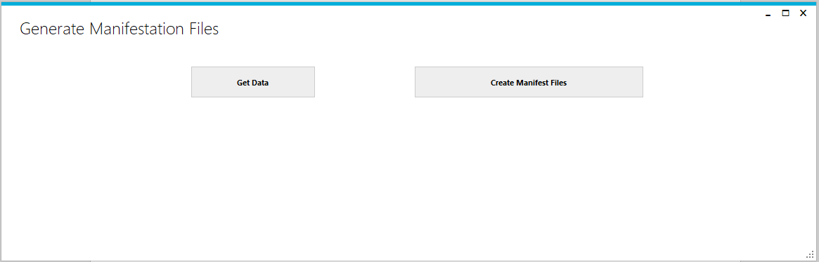

**Requirements: DB2 drivers installation first.**

**Driver location:** F:\FTP\GBO\DB2\v11.1.2fp2_nt32_client\CLIENT

1. **Import Manifestation (KHI)**

**Description:** To creation of EDI files for manifest, downloading documents from edoc and generating draft emails for all import shipments to respective recipients of carrier lines created an application which gathers data from BRDB and create manifest files and draft accordingly. User just need to review the email and send it to respective line.

**Stakeholders:** Hammad Khan, Amin Gang, Safia Khannum

**Location:** LHE F:\FTP\GBO\FaisalTransition\Import Manifestation\

**Tools and Tech:** .Net C# application

1. **PreAlerts Tool (KHI, LHE)**

**Description:** Replicated a tool from India IS to send out automated alerts along with information of shipment using Visibility.

**Stakeholders:** Imran Khan, Amin Gang

**Location:** LHE F:\FTP\GBO\FaisalTransition\PreAlert Tool\

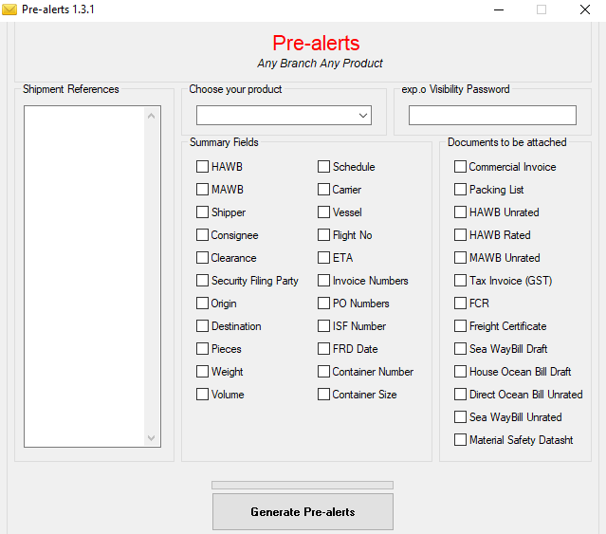

**Documentation/Video:** F:\FTP\GBO\FaisalTransition\PreAlert Tool\JobAid

Instructions and Guide for Configurations

**General Installation for Python and its Configurations:**

F:\FTP\GBO\FaisalTransition\General Python Setup and Configuration.docx

**Followed Desktop Scripts Documentation:**

<http://globalhelp.chq.ei:8888/globalhelp/dst/Desktop_Scripting_Training.htm>